Promoted for and on behalf of Cycling Time Trials under their rules and regulations

B&DCC CARR LANE HILL CLIMB

Sunday 11th October 2020
COURSE : OHC 12
START 14:01 HRS
NO HQ facilities but sign on /off will be at – Palterton Village Hall Back Lane; Palterton; Chesterfield S44 6UN

Course record Men – Adam Kenway 2m 56.2 2017 Women – Alex Deck 4m16.7 2017
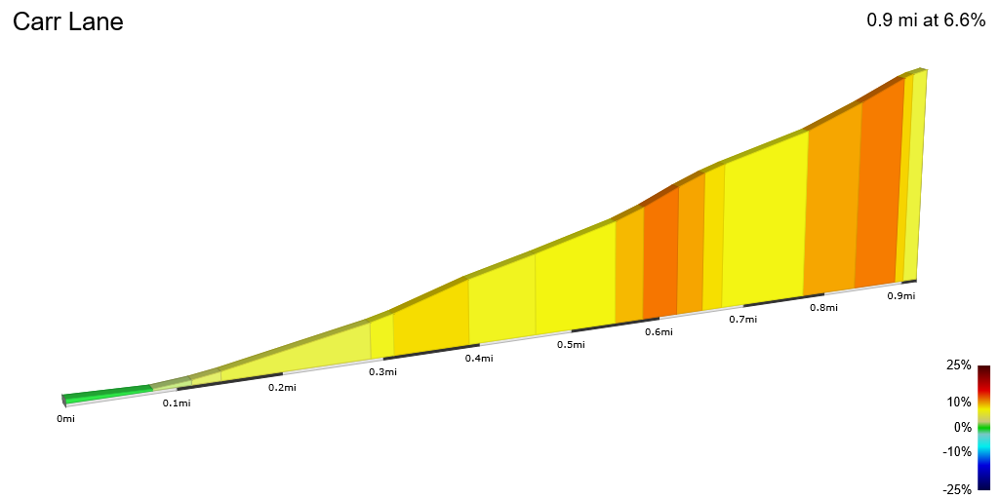

With permission of

Time Keepers:- Malcolm Smith & Mark Bridgman Smith
Event Sec:-Jonathan Wardle, 6 Woodside Close Chesterfield S40 4PW

07712481492

Please park sensibly and minimise impact on the good folk of Palterton at this time.

- We politely ask that riders seek to minimise their time in Palterton. There are no toilet facilities so please go before you arrive ☺.
- We are setting up online results as soon as possible after the race. Do not approach the time keepers for information. This could result in a DQ.

ALSO: BMCR are holding an event on the same course from 12:31 so there will be no opportunity to warm up on the hill.

AWARDS
MEN | VETS (M & F)) | WOMEN | JUNIORS  (M & F) | ESPOIR (M & F)
20 | 20 | 20 | 20 | 20
15 | 15 | 15 | 10 | 10
10 |  | 10

There will be no prize giving at the event . Awards will be transferred after the event

North Midlands District CTT Information
No warming up on the course once the event has started
And Finally
1 | 14:01:00 | James Lonsdale | Bolsover and District CC | Male | Espoir
2 | 14:02:00 | Roger Widdowson | Sherwood CC | Male | Veteran
3 | 14:03:00 | Alfie Thompson | Leicestershire RC | Male | Espoir
4 | 14:04:00 | Mark Tomlinson | Peterborough CC | Male | Senior
5 | 14:05:00 | Tom Foreman | Sherwood CC | Male | Senior
6 | 14:06:00 | Lilja Raine | myhillcycling.co.uk | Female | Junior
7 | 14:07:00 | Kevin Raine | myhillcycling.co.uk | Male | Veteran
8 | 14:08:00 | Jon Wild | Veloviewer | Male | Veteran
9 | 14:09:00 | Rebecca Lineker | South Normanton C C | Female | Senior
10 | 14:10:00
11 | 14:11:00 | Daniel Ward | South Normanton C C | Male | Senior
12 | 14:12:00 | Matthew Beech | Ilkeston Cycle Club | Male | Veteran
13 | 14:13:00 | Russell Jelly | Mapperley CC | Male | Veteran
14 | 14:14:00 | Matthew Calvert | Matlock CC | Male | Juvenile
15 | 14:15:00 | Richard Knowles | Stafford RC | Male | Veteran
16 | 14:16:00 | Oliver Smee | Ilkeston Cycle Club | Male | Senior
17 | 14:17:00 | Tim Phillips | Team Catenary | Male | Veteran
18 | 14:18:00 | Andy Smith | Mansfield Road Club | Male | Veteran
19 | 14:19:00 | Chris Kaye | Ilkeston Cycle Club | Male | Veteran
20 | 14:20:00 | Brian Whiteley | Doncaster Wheelers C.C. | Male | Veteran
21 | 14:21:00 | Laurie Stobbs | Ilkeston Cycle Club | Male | Veteran
22 | 14:22:00 | Tobias Edwards | Team Lifting Gear Products/Cycles In Motion | Male | Espoir
23 | 14:23:00 | Daniel Farrand | Bolsover and District CC | Male | Veteran
24 | 14:24:00 | Mark Rowbottom | Chesterfield Coureurs CC | Male | Senior
25 | 14:25:00 | Barry McDonald | 3T-RACING | Male | Veteran
26 | 14:26:00 | Darren Miller | Fusion Cycling Club Dronfield | Male | Senior
27 | 14:27:00
28 | 14:28:00 | Richard Stoodley | TrueSapien | Male | Veteran
29 | 14:29:00 | Harry Thompson | Leicestershire RC | Male | Senior
30 | 14:30:00
31 | 14:31:00 | Tim Glenie | Ilkeston Cycle Club | Male | Veteran
32 | 14:32:00 | Jules Chadderton | Huddersfield Star Whs | Male | Junior
33 | 14:33:00 | Simon Warren | Norwood Paragon CC | Male | Veteran
34 | 14:34:00 | Nick Burton | Newark Castle C C | Male | Veteran
35 | 14:35:00 | Jerome Jacob | 7 Hills Cycling Club | Male | Senior
36 | 14:36:00 | Sonia Insley | Bolsover and District CC | Female | Veteran
37 | 14:37:00 | Tony Cope | Leek CC - Den Engel Belgian Bar | Male | Veteran
38 | 14:38:00 | Christopher Peach | Ilkeston Cycle Club | Male | Senior
39 | 14:39:00 | Darrell Clarke | Ilkeston Cycle Club | Male | Veteran
40 | 14:40:00 | Charlie Openshaw | Islington Cycling Club | Male | Veteran
41 | 14:41:00 | Sandra MacKay | Datalynx-Parenesis Cycling | Female | Veteran
42 | 14:42:00 | Pete Laud | Common Lane Occasionals | Male | Veteran
43 | 14:43:00 | Nicholas Latimer | Team Lifting Gear Products/Cycles In Motion | Male | Senior
44 | 14:44:00 | James King | OVB | Male | Senior
45 | 14:45:00 | Paul Armstrong | Team Lifting Gear Products/Cycles In Motion | Male | Senior
46 | 14:46:00 | Hamish McDougall | Team Lifting Gear Products/Cycles In Motion | Male | Senior
47 | 14:47:00 | Will Beech | Beeston Cycling Club | Male | Espoir
48 | 14:48:00 | Luke Hind | Team Lifting Gear Products/Cycles In Motion | Male | Espoir
49 | 14:49:00 | Ewan Mackie | HMT Hospitals Giant Cycling Team | Male | Junior
50 | 14:50:00 | John Hind | Bolsover and District CC | Male | Veteran
51 | 14:51:00 | Tom Hazelton | Dulwich Paragon CC | Male | Senior
52 | 14:52:00 | James Byatt | Ilkeston Cycle Club | Male | Senior
53 | 14:53:00 | Nicola Soden | Datalynx-Parenesis Cycling | Female | Senior
54 | 14:54:00 | Ben MacKinson | Apache Brave Racing | Male | Senior
55 | 14:55:00 | Tom Bell | High North Performance | Male | Senior
56 | 14:56:00 | Richard Gildea | Didcot Phoenix CC | Male | Senior
57 | 14:57:00 | Adam Kenway | VITUS PRO CYCLING Powered by BROTHER UK | Male | Senior
58 | 14:58:00 | Hannah Bayes | Liv AWOL | Female | Espoir
59 | 14:59:00 | David Fellows | Solihull CC | Male | Senior
60 | 15:00:00 | Haddi Conant | Team Lifting Gear Products/Cycles In Motion | Female | Espoir
61 | 15:01:00 | Cameron Biddle | Vredestein Basso | Male | Espoir
62 | 15:02:00 | Mary Wilkinson | Yorkshire Road Club | Female | Senior
63 | 15:03:00 | Andy Nichols | Team Lifting Gear Products/Cycles In Motion | Male | Senior
64 | 15:04:00 | Kieran Smith | Team Lifting Gear Products/Cycles In Motion | Male | Junior

